|  |
| --- |
| **Potato Integrated Technologies**  **PI-1500**  **Teleoperated Robot Module**  **User Manuel**    **PI-1501 PI-1521** |

**TABLE OF CONTENT**

1. **INTRODUCTION______________________________________________ 2**
2. **SAFETY INFORMATION________________________________________ 2**
3. **PI-1500 ROBOT ______________________________________________ 3**
4. **PI-1521 TELECONTROLLER _____________________________________ 4**
5. **BATTERIES__________________________________________________ 5**
   1. **CONNECTING AND DISCONNECTING ________________________ 5**
   2. **CHARGING _____________________________________________ 6**
   3. **REPLACEMENT __________________________________________ 6**
   4. **NOTES FOR BATTERIES____________________________________ 7**
6. **USE _______________________________________________________ 8**
7. **CARE AND MAINTANCE _______________________________________ 9**
8. **INTRODUCTION**

With PI-1500 module you can precisely control the PI-1501 Robot from a distant location using PI-1521 Telecontroller. The communication between robot and controller has a range of more than 30 Meter indoor.

1. **SAFETY INFORMATION**

* Carefully read instruction manual before taking the device into operation. Heed all safety warnings to avoid personal injury due to misuse.
* If transferring this device to third party, the user manual must also be passed on to the recipient.
* No liability can be accepted for any damage incurred as a result of improper use.
* Do not use these products for development, design, manufacture, or production of nuclear missile, or chemical weapon or biological weapons. Failing that might cause serious injuries, minor casualties and US invasion.
* This device is not suitable for use by persons with limited physical, sensory or mental abilities (including children), or used by persons with limited experience and/or knowledge of this device unless they possess the relevant safety knowledge or instructions on how the device is to be used.
* Do not insert third party components to module. Only use PI TECH approved components. Use of non-approved components may damage it or may cause injury to you.
* Never leave batteries connected after the operation.
* Do not use the device in close proximity to heat radiating devices or leave under the direct sunlight.
* Do not submerge the device in water and do not use the device in close proximity to water.
* Do not use the device if it is damaged. To avoid hazards, defective components must only be replaced by the manufacturer, his customer service or similar qualified persons.
* Never attempt to repair the device yourself. Repairs should only be carried out by qualified persons.
* Do not drop or impact the devices.
* Do not overload the devices.

1. **PI-1501 ROBOT**

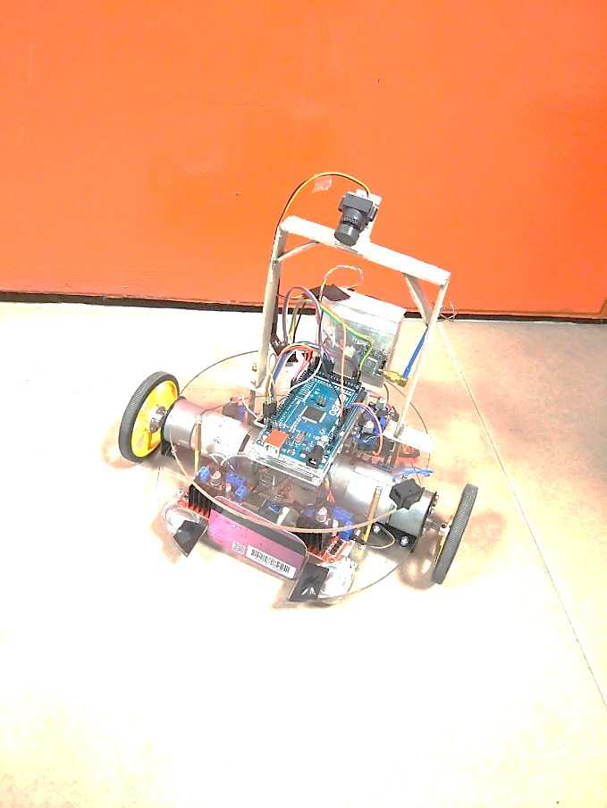 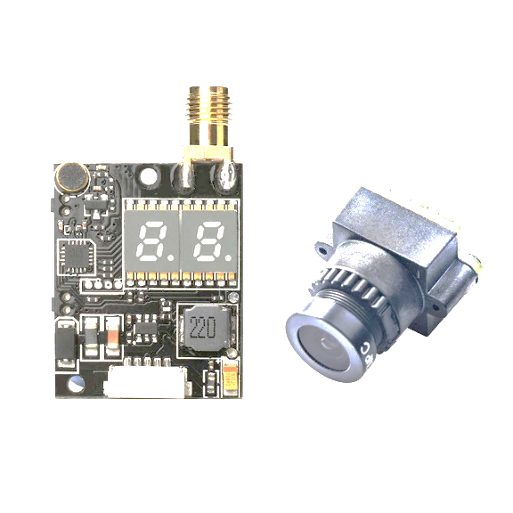

4

5

3

2

7

9

8

6

1

1. Camera
2. Transmitter
3. ON/OFF switch
4. Shooting surface
5. Band-up button
6. Frequency-up button
7. Antenna connection
8. Channel
9. Frequency
10. **TELECONTROLLER PI-1521**

seven seg png ile ilgili gÃ¶rsel sonucuseven seg png ile ilgili gÃ¶rsel sonucu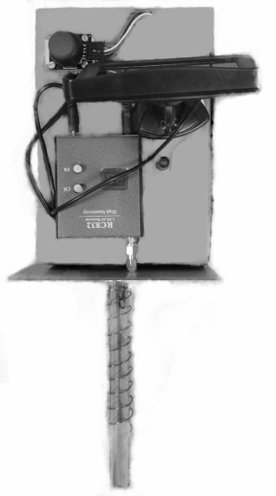 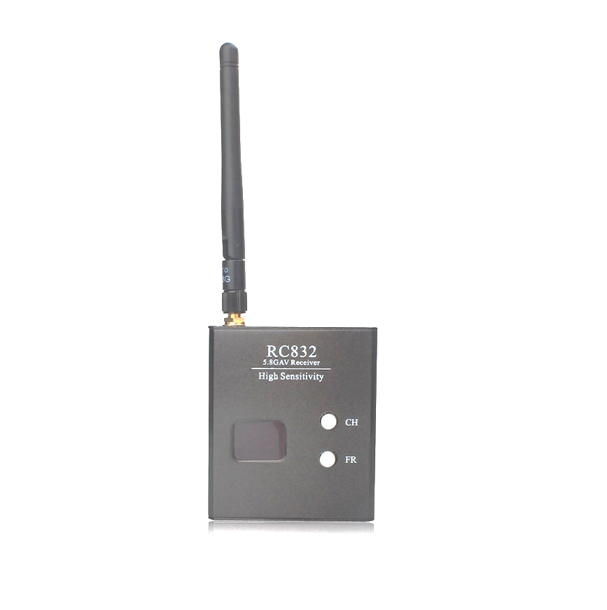

12

11

13

17

15

16

10

14

1. Receiver antenna
2. Video receiver
3. Video display (Screen)
4. ON/OFF switch (Right side)
5. Joystick
6. Antenna connector
7. Channel Display (Left: Band, Right: Frequency)
8. Channel Up buttons (Up: Band-up, Down: Frequency-up)
9. **BATTERIES**
   1. **CONNECTING AND DISCONNECTING**

This module works with 2 Lithium Polymer (Li-Po) batteries, 3S 1350mAh battery for PI-1501 robot and 3S 1000mAh battery for PI-1521 telecontroller. For your safety read 5.4. “Notes for Batteries” section carefully.

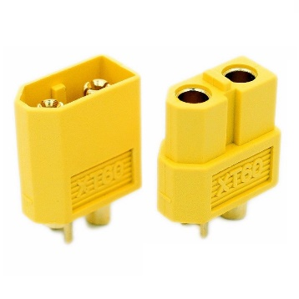 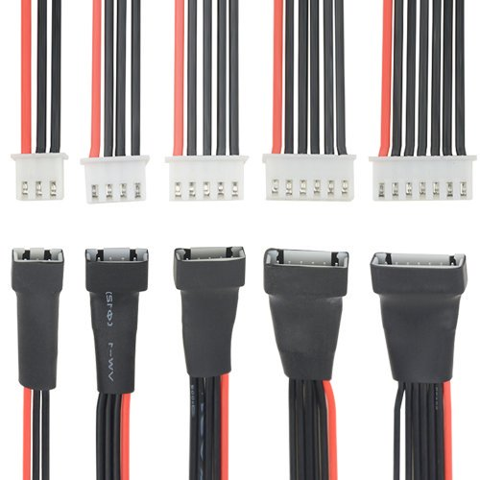

21

20

19

18

1. Female Li-Po connector
2. Male Li-Po connector
3. Male balance connector
4. Balance charge connector port

**Connection**

* Control the voltage of battery, never use empty battery.
* Control that power switch of the device is OFF.
* Connect only male connector of robot with female connector of module. Do not try to connect other connectors.

**Disconnection**

* Turn the power switch OFF.
* Separate only male Li-Po connector of robot from female Li-Po connector of module.
  1. **CHARGING**
* Control that power switch of the device is OFF
* Disconnect the battery following provided disconnection instructions.
* Separate batteries from the module.
* For best performance use Li-Po balance charger.
* Connect Li-Po charger to power grid.
* Choose “Balance Charge” mode.
* Adjust charger to 3S mode.
* Adjust current mode. (1.3 Amp for 1350mAh, 1 Amp for 1000mAh battery)
* Connect male Li-Po connector to female Li-Po port of charger.
* Connect balance connector of Li-Po to balance connector port of charger.
* Press and hold “Start” button for 5 second.
* Charging will start with a “Beep” sound.
* When charging ended charger will create “beep” sound.
* Upon completion of charging, press stop button and separate Li-Po from charger.
* Disconnect Li-Po charger from the power grid.
  1. **REPLACEMENT**
* Control that power switch of the device is OFF
* Disconnect the battery following provided disconnection instructions.
* Separate old batteries from the module.
* Dispose the batteries following the instructions provided in 5.4. “Notes for Batteries”.
* Before buying new batteries carefully read notes for batteries section and only use 3S Li-Po batteries. Using batteries not compatible with this device might cause undesired results.
* Connect batteries to the device following provided connection instructions.
  1. **NOTES FOR BATTERIES**
* Only use top-quality batteries. Cheap batteries could leak and damage the device as a result.
* Never use batteries with different specifications. This will harm electronics on devices or cause short circuits.
* If batteries leak, remove them with a cloth and dispose of them accordingly. Ensure that leaking battery acid does not come into contact with skin and eyes.
* Avoid prolonged skin contact with the charging cable and connector when the charging cable is connected to a power source because it may cause discomfort or injury. Sleeping or sitting on the charging cable or connector should be avoided.
* If the device is not to be used for extended period of time, then the batteries should be removed, as the device or batteries could become damaged. For long storage times, all batteries should be stored separated from the devices.
* Only use “made for Li-Po charging” chargers. Do not use not-clearly stated   
  Li-Po chargers or other third-party devices. Charging with such adapters could pose a risk of death or injury.
* Batteries does not belong in household waste! Expired batteries must be disposed of in an environmentally friendly way and according to the applicable legal regulations.
* Do not put batteries in close proximity to heat sources or leave under the direct sunlight.
* Batteries must not be recharged or activated with other means, dismantled, thrown into fire or short-circuited.
* Remove the batteries prior to disposing of the devices.

1. **USE**

**Preparing PI-1501 Robot**

* Place the robot on a solid operation field.
* Control the connection of the battery.
* Power up the robot using switch.
* Wait until transmitter light is on and channel screen showing current channel.

**Preparing PI-1521 Telecontroller**

* Place the controller on a solid surface.
* Power up the controller using switch.
* Wait until screen display any visual.
* Take controller from its place and hold the controller.
* Direct the antenna towards the robot, the display shows camera data from the robot.

**Controlling PI-1501 Robot with PI-1521 Telecontroller**

* To control the robot using telecontroller ensure both devices powered up and ready for operation.
* The robot has 5 basic commands and 4 precision command. When controller antenna directed to the opposite side to user these commands performed respect to position of joystick. Base operations;
  + Front: Robot move forward.
  + Back : Robot move backward.
  + Right: Robot turn clockwise.
  + Left : Robot turn counterclockwise.
  + Press: Shoot
* For precision operations joystick must be slightly moved toward desired operations.
  + Slightly Front: Robot move forward slowly.
  + Slightly Back : Robot move backward slowly.
  + Slightly Right: Robot turn clockwise slowly.
  + Slightly Left : Robot turn counterclockwise slowly.

**Setting Video Transmitter Channel**

Video Transmitter has 6 channels and 6 frequencies for each band. For clear video transmission both transmitter and receiver use same channel and frequency.

* Power on the robot and controller.
* Set video transmitter channel and frequency respectively using respected buttons shown in Section 2.
* Set video receiver channel and frequency respectively using respected buttons shown in Section 3.

1. **CARE AND MAINTANCE**

* For longer battery life batteries should be stored separately from the devices.
* When storing, always cover the device.
* If the device is not to be used for extended period of time, voltage level of batteries should be controlled and if voltage drops under certain limit, batteries must be charged.
* Devices should be preserved carefully. Clean, dry and cool places with no solar exposure should be chosen.
* Do not put devices in close proximity to any heat source.
* Avoid storing the device close to any radiation emitting device or material.
* Storage in any humid environment or close to water source is not recommended.
* Do not use alcohol, acetone, benzene, scouring cleaning agents, etc., to clean the devices. Do not use hard brushes or metallic objects.